◆ Research paper
DOI: 10.5281/zenodo.XXXXXX
Abc XXXXX title
Author^{1*}, Author²
¹Department of XXX, University of XXX, City, Country
²Department of YYY, University of YYY, City, Country

* Corresponding author Email: XX@xx.com

Abstract: Groundwater samples. ………

Keywords: Key1, key2, key3.

Introduction

Toxicity of a ( Ehrlich, 2002; Oremland and Stolz, 2003). Sdfghjk ^{[1-3]}, anscdf. Abcdefg. anscdf. Abcdefg. anscdf. Abcdefg. anscdf. Abcdefg. Shown in Table 1.
Arsenic is naturally occurring element available in soil and sediments (Korte, 1991)
Table1 XXX
 | Nitrate mg/L | Spectrophotometer, HACH-8171
 | Hardness as CaCo₃ | EDTA titration standard method (1992)
 | iron | Spectrophotometer (Model: U-1100, HITACHI)
 | Fluoride | Spectrophotometer, SPADNS (HACH).
 | Arsenic | Perkin Elmer A Analyst 600 Graphite Furnace Atomic Absorption Spectrophotometer

The Mechanical relationship between ball particles and walls is shown in Figure 1.

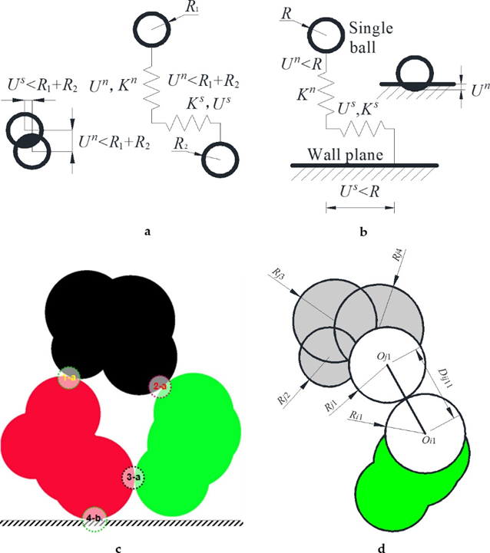
Figure 1. Mechanical relationship between ball particles and walls
(a). mechanical model of in-teraction between single ball particles; (b) mechanical model of interaction between particle and wall plane. (c) the relationships. R1, R2 are the radii of single particles; Kn is the elastic stiffness, and Ks is the shear stiffness. The black shaded area overlaps the ball particles between the ball particles and the wall plane. Three joint particles are red, green, and black, which contact each other. There is a wall plane at the bottom. 1-a, 2-a and 3-a are three contact points between two particles: the contact relationship in (a). 4-b is the contact point between particle and wall, the contact rela-tionship in (b); (d) determination of distance, contact, and extrusion of joint particles.

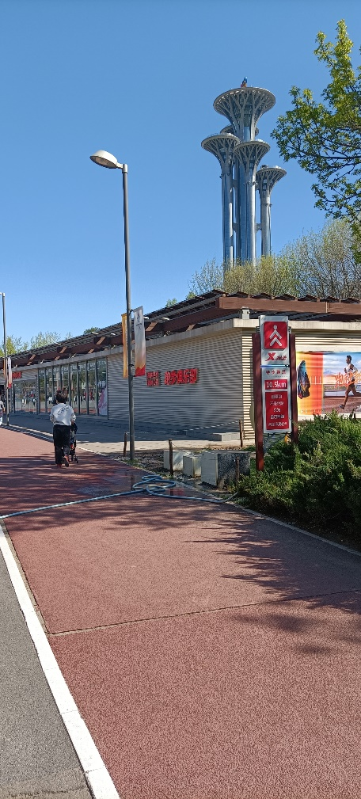
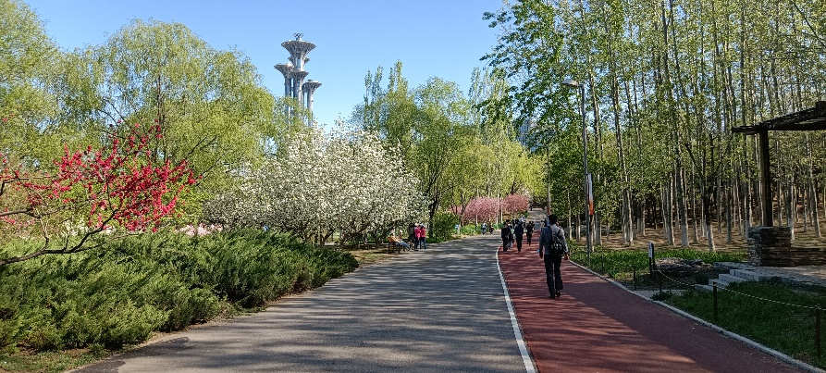
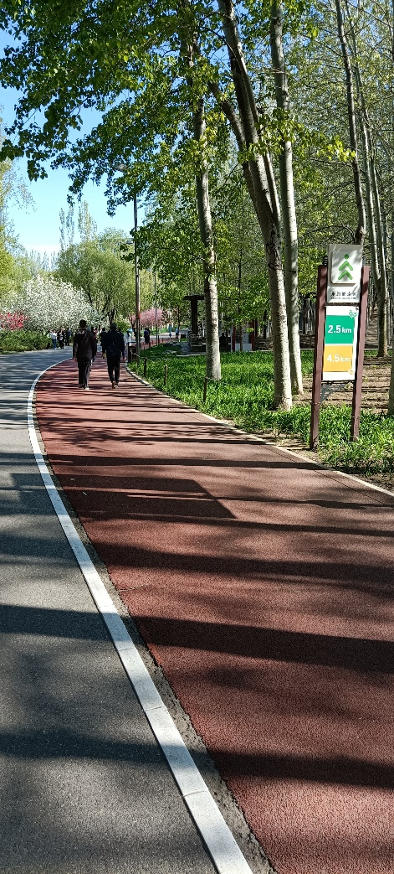
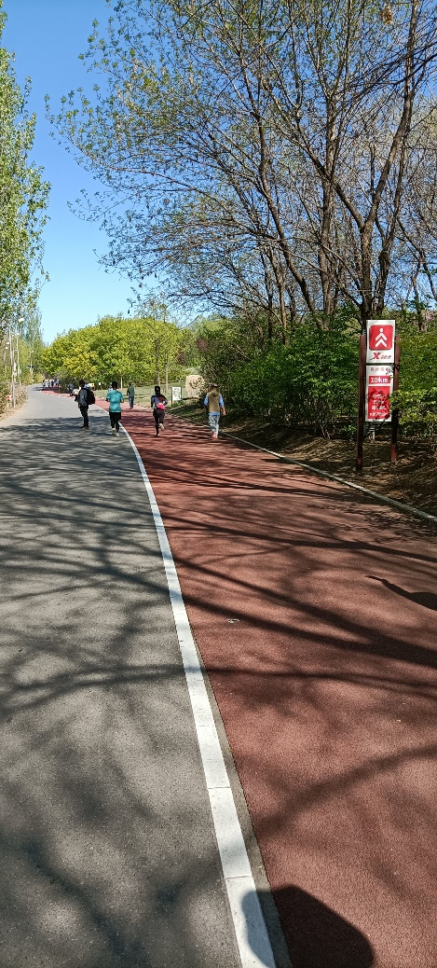
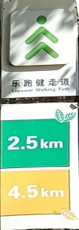
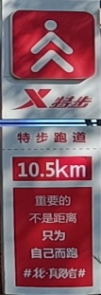

b
a
c
d
b
c
d

Figure 2 Running track in Olympic Forest Park of China
(a) The sightseeing tower and walking/running track in Beijing Olympic Forest Park; (b) 10 km meters sign; (c) 2.5 km and 4.5 meters sign; (d) 10.5 km meters sign

Then according to the design requirements of the slope, mainly according to formula (1).

On the topographic map, the slope formula from a point P₁(x₁, y₁, z₁) to another point P₂(x₂, y₂, z₂) is:
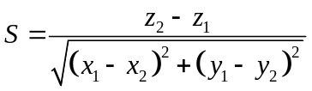 (1)
Where, S is the slope. S>0 means uphill, and S<0 means downhill.
Various local departments have designed and constructed many walking and running routes with people's love for sports, some in some city parks and some in the geological park. As shown in the picture, the three running tracks of Beijing Olympic Forest Park are red, yellow and green, as shown in Figure 2.

Principal component analysis (PCA).
Statistical analysis was, abcd Statistical analysis was, abcd Statistical analysis was, abcdStatistical analysis was, abcd Statistical analysis was, abcd.

Results and Discussion
Major Chemistry
Mean total dissolved solids (TDS) content is proximal in all three sites but a wide variation range of TDS occurs in the order of SB (469-3596 mg/L) > TS (372-2458 mg/L) > LK (490-3148 mg/L). This wide variation in the salinity of groundwater is mainly attributed to anthropogenic activities and geochemical processes (Jeevanandam et al., 2007) prevailing in the study area.

Conclusion

Reference
[1] Sun Jichao. Hard particle force in a soft fracture. Scientific Reports, 2019, 9: 3065.
[2] Sun Jichao. Permeability of particle soils under soil pressure. Transport in Porous Media, 2018, 123(2): 257-270.
[3] Sun Jichao, Huang Yuefei. Modeling the Simultaneous Effects of Particle Size and Porosity in Simulating Geo-Materials. Materials, 2022, 15(4): 1576.

Of course you can choose another references format version
Voudouris K., Panagopoulos, A., Koumantakis, J. (2004b), Nitrate pollution in the coastal aquifer system of the Korinthos Prefecture (Greece). Global Nest: The International Journal, 6(1), 31-38.
Voudouris, K.S., Daskalaki, P., Antonakos, A. (2005). Water resources and groundwater quality in North Peloponnesus. Global NEST Journal, 7(3), 340-353.
Wagner, F., Berner, Z., Stüben, D., 2005. Arsenic in groundwater of the Bengal Delta Plain: geochemical evidences for small scale redox zonation in the aquifer. In: Bundschuh, J., Bhattacharya, P., Chandrashekharam, D. (Eds.), Natural Arsenic in Groundwater: Occurrence, Remediation and Management. AA Balkema/Taylor & Francis group, London, 3–15.
Wilson, L.G., 1981. The fate of pollutants in the vadose zone, monitoring methods End case studies. In: Proceedings of the Thirteenth Biennial Conference on Ground Water, Irvine California Water Resources Center, University of California, Davis.



This paper DOI: 10.5281/zenodo.XXXXXX
Journal New Website web1: https://ijgsw.eu.org/
web2: https://ijgsw.net/
Journal Old Website: http://ijgsw.comze.com/ is no longer used
You can submit your paper to email: Jichao@email.com
Or IJGSW@mail.com

